Chapter 10, Problem 50.

Using Fig. 10.95, design a problem to help other students understand source transformation.
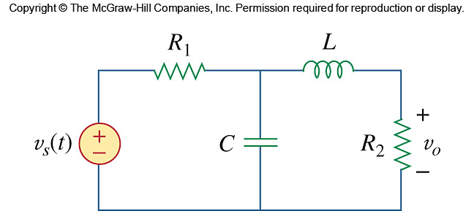

Figure 10.95
For Prob. 10.59.

